

LIBERTY ELECTRONICS

### Our Team

|  |  |  |
| --- | --- | --- |
| **Team Name** | MSG-Achiever | |
| **Serial Number** | **Enrollment Number** | **Student Name** |
| 1 | Student1579025 | Ashar John |
| 2 | Student1578590 | AHMED HUSSAIN |
| 3 | Student1560126 | FAIZAN ALI |
|  |  |  |
|  |  |  |
|  |  |  |

# **Abstract:**

Liberty Electronics is a cutting-edge e-commerce platform designed to offer a seamless and enjoyable shopping experience for electronic enthusiasts and everyday consumers alike. Utilizing the latest web technologies, including HTML, CSS, JavaScript, and Bootstrap, Liberty Electronics brings together a vast array of high-quality electronic products under one virtual roof.

Our online store features a user-friendly interface, ensuring that customers can easily navigate through our extensive product catalog. From the latest smartphones and laptops to essential home appliances and accessories, Liberty Electronics provides a comprehensive selection tailored to meet diverse needs.

# **Acknowledgement:**

First of all we would like to thank Almighty Allah for giving us strength and ability to complete this project.

I would like to acknowledge all those who have given morals support and helped me make the project a success.

I wish to express my gratitude to the Sir Amjad, who guided and helped me. I would also like to express my gratitude to all the team members of my group as well as my class teacher for not only providing me with the opportunity to work with them on this project, but also for their support and encouragement throughout the process.

And finally, I would like to offer many thanks to all my colleagues for their valuable suggestion and constructive feedback.

Contents

**Our Team** 1

**1.** **Abstract:** 2

**2.** **Acknowledgement:** 3

**3.** **Introduction:** 5

**4** **Scope of Project:** 5

**5** **Problem Statement:** 7

**6** **Functional Requirement:** 9

**6.1Catalog Display:** 9

**6.2 Search and Navigation:** 9

**6.3** **Product Information:** 9

**6.3.1** **Smartphones** 9

**6.4 Shopping Cart and Checkout:** 10

**6.5** **Contact Us:** 10

**7** **Non-Functional Requirement:** 10

**7.1 Safe to use:** 11

**7.2 Accessible:** 11

**7.3 User-friendly:** 11

**7.4 Operability:** 11

**7.5 Performance:** 11

**7.6 Capacity:** 11

**7.7 Availability:** 11

**7.8 Compatibility:** 11

**8** **Proposed Solution:** 11

**9** **Hardware And Software Requirement:** 13

**9.1 Hardware Requirement:** 13

**9.2 Software Requirement:** 13

**10** **Screen Shot:** 14

**10.1** **Home:** 14

**10.2** **About:** 15

**10.3 Contact Us** 16

**12 Conclusion:** 18

# **Introduction:**

Welcome to Liberty Electronics, your premier destination for all things electronic! This cutting-edge online e-commerce platform has been meticulously crafted using HTML, CSS, JavaScript, and Bootstrap to bring you a seamless and enjoyable shopping experience. At Liberty Electronics, we understand the importance of having access to the latest and greatest in technology, and we are here to make that journey smooth and hassle-free.

Our user-friendly website showcases a vast array of high-quality electronic products, ranging from the newest smartphones and high-performance laptops to essential home appliances and must-have accessories. Whether you're a tech enthusiast looking to stay ahead of the curve or simply in need of reliable electronics for everyday use, Liberty Electronics has something for everyone.

With a focus on responsive design, custom layouts, and secure transactions, we strive to provide an exceptional user experience that keeps our customers coming back. Explore Liberty Electronics today and discover a world where technology meets convenience, all at your fingertips. Join us in the revolution of online shopping and experience the future of electronics retail.

# **Scope of Project:**

Liberty Electronics aims to create a comprehensive and user-friendly online e-commerce platform for electronic products. The scope of this project includes the following key components:

Website Development:

Front-End Development: Using HTML, CSS, JavaScript, and Bootstrap to design a visually appealing and responsive website that ensures an excellent user experience across all devices.

Responsive Design: Implementing a mobile-first approach to ensure the website is accessible and functional on smartphones, tablets, and desktops.

Product Catalog Management:

Product Listings: Setting up a comprehensive catalog of electronic products, including smartphones, laptops, home appliances, and accessories.

Product Details: Providing detailed descriptions, high-quality images, specifications, and pricing for each product.

User Interface (UI) and User Experience (UX) Design:

Intuitive Navigation: Creating a user-friendly interface with easy navigation to enhance the shopping experience.

Interactive Elements: Incorporating dynamic elements to improve user engagement, such as product filters, search functionality, and interactive product galleries.

E-commerce Functionality:

Shopping Cart and Checkout: Developing a secure and efficient shopping cart system and a streamlined checkout process

# **Problem Statement:**

In today’s rapidly evolving digital landscape, consumers expect seamless and efficient online shopping experiences, especially when it comes to purchasing electronic products. However, many e-commerce platforms struggle to meet these expectations due to outdated designs, slow loading times, and a lack of responsive functionality. This results in frustrated users, increased bounce rates, and ultimately, lost sales opportunities.

Liberty Electronics was conceived to address these challenges and provide a superior online shopping experience for electronics enthusiasts and everyday consumers. The primary problems that Liberty Electronics aims to solve include:

Lack of Responsive Design: Many existing e-commerce websites fail to provide a consistent and user-friendly experience across various devices, leading to poor usability on mobile and tablet devices.

Slow Load Times: E-commerce platforms often suffer from slow loading speeds, causing users to abandon their shopping experience before completing a purchase.

Complex Navigation: Users frequently encounter difficulty in navigating large product catalogs, resulting in a frustrating shopping experience and lower conversion rates.

Insecure Transactions: Ensuring the security of customer data and transactions is critical, yet many platforms do not implement adequate security measures, leading to mistrust and reluctance to make online purchases.

Outdated Visual Design: A modern, visually appealing design is essential to attract and retain customers. Many existing platforms fail to keep up with design trends, resulting in outdated and unattractive websites.

Inadequate Product Information: Comprehensive and accurate product information is crucial for informed purchasing decisions. Many websites lack detailed descriptions, high-quality images, and user reviews.

Liberty Electronics aims to overcome these obstacles by creating a fully responsive, fast-loading, and user-centric e-commerce platform. By leveraging the latest web technologies, including HTML, CSS, JavaScript, and Bootstrap, Liberty Electronics will offer a secure, visually appealing, and easy-to-navigate online store that meets the high expectations of today’s consumers. This project will not only enhance the shopping experience but also drive higher customer satisfaction and increased sales for electronic products.

# **Functional Requirement:**

The portal will be designed as a Single-Page-Application (SPA) and responsive Website with a set of pages and menus that represent choice of activities to be performed. The pages, menus, and other visual elements must be designed in a visually appealing manner with attractive fonts, colors, and animations. All of these should also be laid out in a responsive manner.

Following are the functional requirements of the portal:

## **6.1Catalog Display:**

The Website should display a catalog of electronic products available for purchase. Electronic products should be organized into categories, such as smartphone, mobile phone, cameras, fridge, and so on. Users should be able to browse through the catalog and view individual product listings.

Data for this can be hardcoded or retrieved from the JSON/TXT file.

## **6.2 Search and Navigation:**

Users should be able to search for a specific plant by name or keywords. The Website should provide navigation options to access different plant categories and sections.

## **Product Information:**

## **Smartphones**

Product Name: iPhone 13 Pro Max Description: Experience the ultimate performance with the iPhone 13 Pro Max. Featuring the powerful A15 Bionic chip, a stunning 6.7-inch Super Retina XDR display, and an advanced triple-camera system, this smartphone is designed to elevate your mobile experience. With its sleek design, 5G capability, and Pro Motion technology, the iPhone 13 Pro Max delivers unparalleled speed and visual clarity. Available in various colors and storage options.

There are other products as well in the product listing.

## **Shopping Cart and Checkout:**

The shopping cart at Liberty Electronics is designed to provide a seamless and user-friendly experience. Here’s what you can expect:

Easy Management: Add, remove, or update quantities of products in your cart with just a few clicks.

Product Details: View essential information about the items in your cart, including product images, descriptions, prices, and available discounts.

Cart Summary: Get a clear summary of your cart, displaying the total cost, including any applicable taxes and shipping fees.

## **Contact Us:**

Contact Us menu option should enable users to contact the creators of the Website. An email id can be displayed here for contact information.

Users should be able to filter plants based on s

# **Non-Functional Requirement:**

There are several non-functional requirements that should be fulfilled by the Website. The Website should be:

## **7.1 Safe to use:**

* The Website should not result in any malicious downloads or unnecessary file downloads.

## **7.2 Accessible:**

* The Website should have clear and legible fonts, user-interface elements, and navigation elements.

## **7.3 User-friendly:**

* The Website should be easy to navigate with clear items and other elements and easy to understand.

## **7.4 Operability:**

* The Website should operate in a reliably efficient manner.

## **7.5 Performance:**

* The Website should demonstrate high value of performance through speed and throughput. In simple terms, the Website should be fast to load and page redirection should be smooth.

## **7.6 Capacity:**

* The Website should support large number of users.

## **7.7 Availability:**

* The Website should be available 24/7 with minimum downtime.

## **7.8 Compatibility:**

The Website should be compatible with latest browsers.

# **Proposed Solution:**

Liberty Electronics will deliver a modern, user-friendly online store, developed using HTML, CSS, JavaScript, and Bootstrap. The platform will feature a responsive design, fast loading times, secure transactions, and a comprehensive product catalog. With intuitive navigation, advanced search functionality, and ongoing support, we ensure a seamless and enjoyable shopping experience for our customers. This solution aims to enhance user satisfaction and drive business growth by providing a top-tier e-commerce platform for electronic products.

# **Hardware And Software Requirement:**

## **9.1 Hardware Requirement:**

· A minimum computer system that will help you access all the tools in the courses is a Pentium 166 or better

· 64 Megabytes of RAM or better

## **9.2 Software Requirement:**

• Notepad/HTML editor/CoffeeCup

• Angular / Angular JS / React / BootStrap

• Dreamweaver / Figma

• MS IE / Chrome / FireFox / Netscape /MS Edge

# **Screen Shot:**

## **Home:**

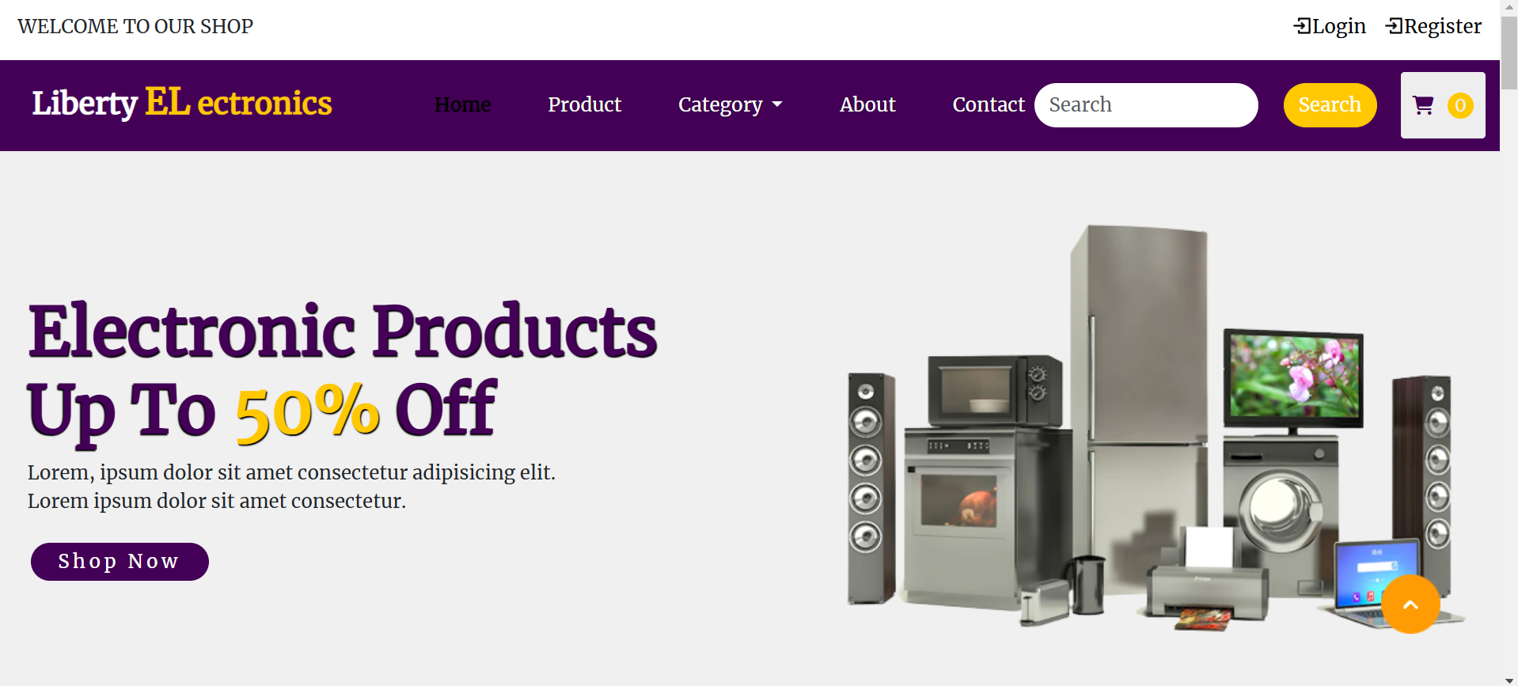

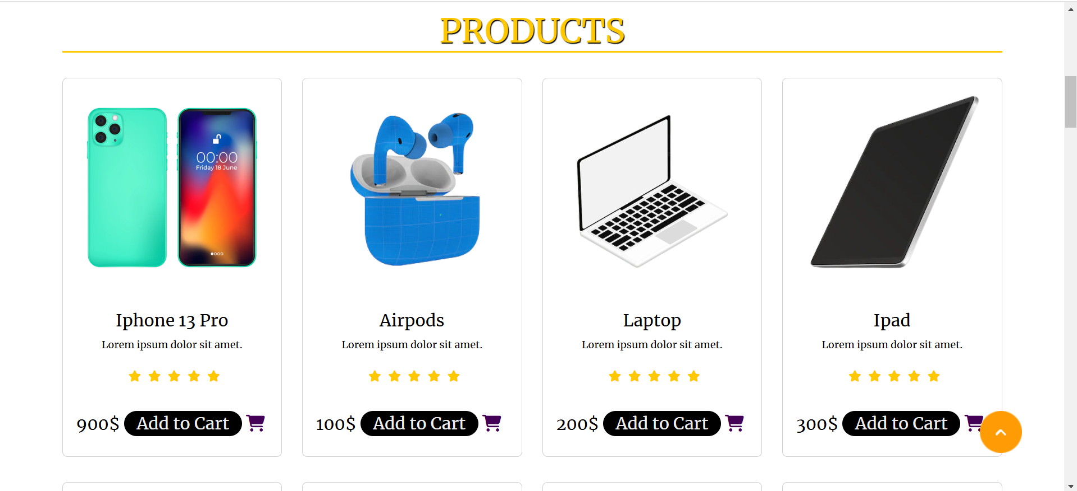

## **10.2 About:**

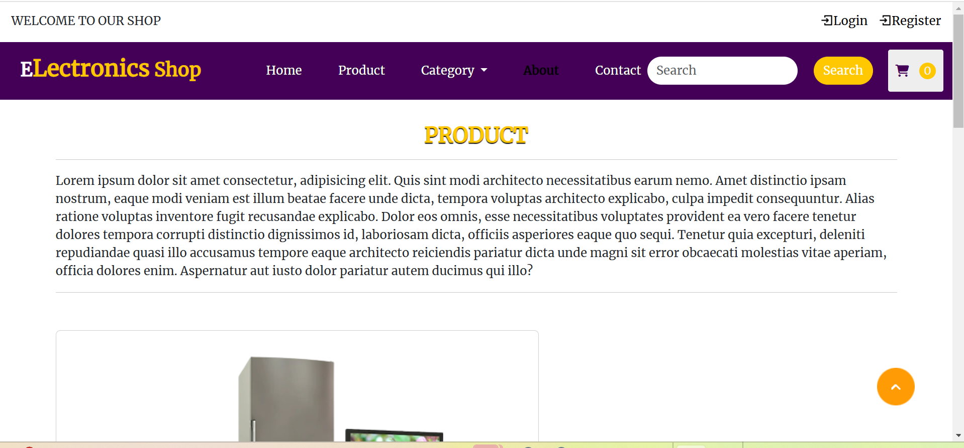

## **10.3 Contact Us**

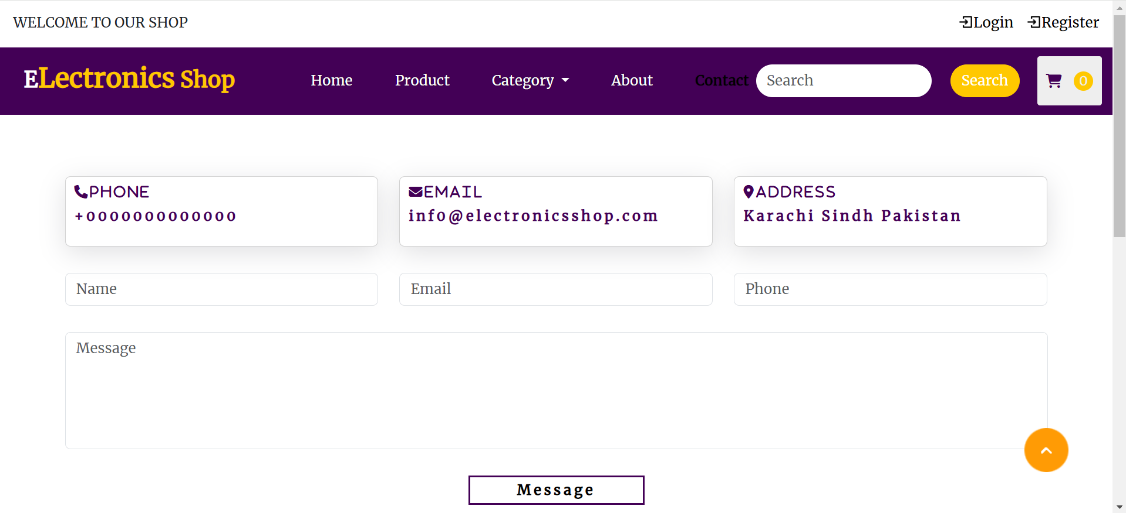

## **11. Task Allocation:**

|  |  |  |  |  |  |
| --- | --- | --- | --- | --- | --- |
| **S.NO** | **TASK** | **START**  **DATE** | **END**  **DATE** | **STUDENT**  **NAME** | **STATUS** |
| 1 | Home page | 15-11-2024 | 16-11-2024 | Ashar John | Complete |
| 2 | Catalog Display | 17-11-2024 | 21-11-2024 | Ashar John | Complete |
| 3 | Add to Cart Design | 22-11-2024 | 24-11-2024 | Ashar John | Complete |
| 4 | Product Information | 25-11-2024 | 26-11-2024 | Faizan and Ahmed | Complete |
| 5 | Shopping Cart and Checkout | 26-11-2024 | 27-11-2024 | Ashar and Faizan | Complete |
| 6 | About | 28-11-2024 | 29-11-2024 | Faizan and Ahmed | Complete |
| 7 | Contact Us | 29-11-2024 | 01-12-2024 | Ashar | Complete |
| 8 | Login & Registration | 02-12-2024 | 03-12-2024 | Ashar | Complete |
| 9 | Documentation | 05-12-2024 | 06-12-2024 | Ashar | Complete |

# **12 Conclusion:**

Liberty Electronics represents a significant step forward in delivering a high-quality, user-centric online shopping experience for electronic products. By leveraging modern web technologies like HTML, CSS, JavaScript, and Bootstrap, we have created a platform that is not only visually appealing but also highly functional and secure. Our focus on responsive design ensures that customers enjoy seamless navigation across all devices, while fast loading times and secure transactions build trust and enhance user satisfaction.

The comprehensive product catalog, combined with intuitive navigation and advanced search capabilities, allows users to find exactly what they need quickly and efficiently. With ongoing support and maintenance, Liberty Electronics is committed to staying updated with the latest trends and technologies, ensuring continuous improvement and long-term success.

In summary, Liberty Electronics is set to become a go-to destination for tech enthusiasts and everyday consumers alike, offering a seamless, engaging, and reliable shopping experience. We look forward to helping our customers discover the latest in electronic innovations and meeting their diverse needs with excellence and professionalism. Thank you for choosing Liberty Electronics as your trusted online electronics store.

THANKS